Heart Attack Prediction

Dataset description
This dataset consists of 13 features and a target variable. It has 8 nominal variables and 5 numeric variables. The detailed description of all the features are as follows:
- age: The person’s age in years
- sex: The person’s sex (1 = male, 0 = female)
- cp: chest pain type — Value 0: asymptomatic — Value 1: atypical angina — Value 2: non-anginal pain — Value 3: typical angina
- trestbps: The person’s resting blood pressure (mm Hg on admission to the hospital)
- chol: The person’s cholesterol measurement in mg/dl
- fbs: The person’s fasting blood sugar (> 120 mg/dl, 1 = true; 0 = false))
- restecg: resting electrocardiographic results — Value 0: showing probable or definite left ventricular hypertrophy by Estes’ criteria — Value 1: normal — Value 2: having ST-T wave abnormality (T wave inversions and/or ST elevation or depression of > 0.05 mV)
- thalach: The person’s maximum heart rate achieved
- exang: Exercise induced angina (1 = yes; 0 = no)
- oldpeak: ST depression induced by exercise relative to rest (‘ST’ relates to positions on the ECG plot.)
- slope: the slope of the peak exercise ST segment — 0: downsloping; 1: flat; 2: upsloping 0: downsloping; 1: flat; 2: upsloping. 12.target: Heart disease (1 = no, 0= yes)

Importing Libraries
!pip install plotly
Requirement already satisfied: plotly in c:\users\divyan\anaconda3\lib\site-packages (4.14.3)
Requirement already satisfied: six in c:\users\divyan\anaconda3\lib\site-packages (from plotly) (1.16.0)
Requirement already satisfied: retrying>=1.3.3 in c:\users\divyan\anaconda3\lib\site-packages (from plotly) (1.3.3)
import numpy as np # linear algebra
import pandas as pd # data processing, CSV file I/O (e.g. pd.read_csv)
import matplotlib.pyplot as plt
import seaborn as sns
import missingno as msno
import plotly.offline as py
py.init_notebook_mode(connected=True)
import plotly.graph_objs as go
import plotly.tools as tls
import plotly.express as px
%matplotlib inline
sns.set_style("whitegrid")
plt.style.use("fivethirtyeight")
from plotly.offline import iplot
from sklearn.linear_model import LogisticRegression
from sklearn.neighbors import KNeighborsClassifier
from sklearn.naive_bayes import GaussianNB
from sklearn.tree import DecisionTreeClassifier
from sklearn.ensemble import RandomForestClassifier
from sklearn.naive_bayes import BernoulliNB
from sklearn.metrics import classification_report
from sklearn.metrics import confusion_matrix
from sklearn.metrics import accuracy_score
from sklearn.decomposition import PCA
import warnings
warnings.filterwarnings("ignore")
data = pd.read_csv("C:/Users/Divyan/Desktop/h.csv")
data
age sex cp trestbps chol fbs restecg thalach exang oldpeak \
0 40 1 2 140 289 0 0 172 0 0.0
1 49 0 3 160 180 0 0 156 0 1.0
2 37 1 2 130 283 0 1 98 0 0.0
3 48 0 4 138 214 0 0 108 1 1.5
4 54 1 3 150 195 0 0 122 0 0.0
... ... ... .. ... ... ... ... ... ... ...
1185 45 1 1 110 264 0 0 132 0 1.2
1186 68 1 4 144 193 1 0 141 0 3.4
1187 57 1 4 130 131 0 0 115 1 1.2
1188 57 0 2 130 236 0 2 174 0 0.0
1189 38 1 3 138 175 0 0 173 0 0.0
slope target
0 1 0
1 2 1
2 1 0
3 2 1
4 1 0
... ... ...
1185 2 1
1186 2 1
1187 2 1
1188 2 1
1189 1 0
[1190 rows x 12 columns]
data.columns
Index(['age', 'sex', 'cp', 'trestbps', 'chol', 'fbs', 'restecg', 'thalach',
'exang', 'oldpeak', 'slope', 'target'],
dtype='object')
data.shape
(1190, 12)
data.info()
<class 'pandas.core.frame.DataFrame'>
RangeIndex: 1190 entries, 0 to 1189
Data columns (total 12 columns):
# Column Non-Null Count Dtype
--- ------ -------------- -----
0 age 1190 non-null int64
1 sex 1190 non-null int64
2 cp 1190 non-null int64
3 trestbps 1190 non-null int64
4 chol 1190 non-null int64
5 fbs 1190 non-null int64
6 restecg 1190 non-null int64
7 thalach 1190 non-null int64
8 exang 1190 non-null int64
9 oldpeak 1190 non-null float64
10 slope 1190 non-null int64
11 target 1190 non-null int64
dtypes: float64(1), int64(11)
memory usage: 111.7 KB
📌 We have 1190 rows and 12 columns in our dataset.
📌 We can see that the dataset contains numerical variables.
#Missing value analysis
data.isnull().sum()
age 0
sex 0
cp 0
trestbps 0
chol 0
fbs 0
restecg 0
thalach 0
exang 0
oldpeak 0
slope 0
target 0
dtype: int64
msno.bar(data, color = 'b', figsize = (10,8))
<AxesSubplot:>
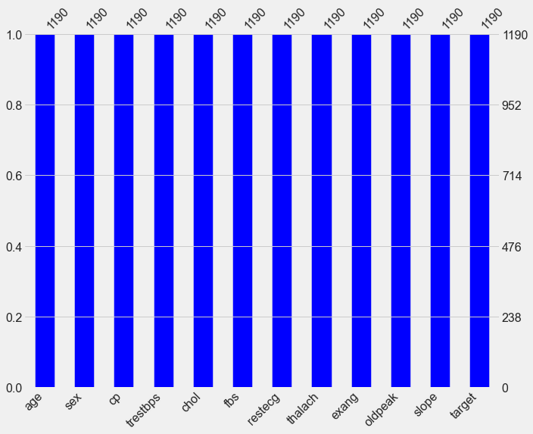
📌 There are no missing values present in our dataset.
data.describe()
age sex cp trestbps chol \
count 1190.000000 1190.000000 1190.000000 1190.000000 1190.000000
mean 53.720168 0.763866 3.232773 132.153782 210.363866
std 9.358203 0.424884 0.935480 18.368823 101.420489
min 28.000000 0.000000 1.000000 0.000000 0.000000
25% 47.000000 1.000000 3.000000 120.000000 188.000000
50% 54.000000 1.000000 4.000000 130.000000 229.000000
75% 60.000000 1.000000 4.000000 140.000000 269.750000
max 77.000000 1.000000 4.000000 200.000000 603.000000
fbs restecg thalach exang oldpeak \
count 1190.000000 1190.000000 1190.000000 1190.000000 1190.000000
mean 0.213445 0.698319 139.732773 0.387395 0.922773
std 0.409912 0.870359 25.517636 0.487360 1.086337
min 0.000000 0.000000 60.000000 0.000000 -2.600000
25% 0.000000 0.000000 121.000000 0.000000 0.000000
50% 0.000000 0.000000 140.500000 0.000000 0.600000
75% 0.000000 2.000000 160.000000 1.000000 1.600000
max 1.000000 2.000000 202.000000 1.000000 6.200000
slope target
count 1190.000000 1190.000000
mean 1.624370 0.528571
std 0.610459 0.499393
min 0.000000 0.000000
25% 1.000000 0.000000
50% 2.000000 1.000000
75% 2.000000 1.000000
max 3.000000 1.000000
📌 The above command df.describe() helps us to view the statistical properties of numerical variables. It excludes character variables.

Exploratory Data Analysis
# Renaming columns.
data.columns = ['Age', 'Sex', 'Chest Pain Type', 'Resting Blood Pressure', 'Cholesterol', 'Fasting Blood Sugar', 'Resting ECG', 'Max. Heart Rate',
'Exercise Induced Angina', 'Previous Peak', 'Slope', 'Condition']
numerical = ['Age','Resting Blood Pressure','Cholesterol','Max. Heart Rate','Previous Peak']
categorical= ['Sex','Chest Pain Type','Fasting Blood Sugar','Resting ECG','Exercise Induced Angina','Slope']

Pie Chart
labels = ['More Chance of Heart Attack', 'Less Chance of Heart Attack']
sizes = data['Condition'].value_counts(sort = True)
explode = (0.05,0)
plt.figure(figsize=(7,7))
plt.suptitle("Number of Targets in the dataset",y=0.9, family='Sherif', size=18, weight='bold')
plt.pie(sizes, explode=explode, labels=labels, autopct='%1.1f%%', shadow=True, startangle=90,)
plt.show()
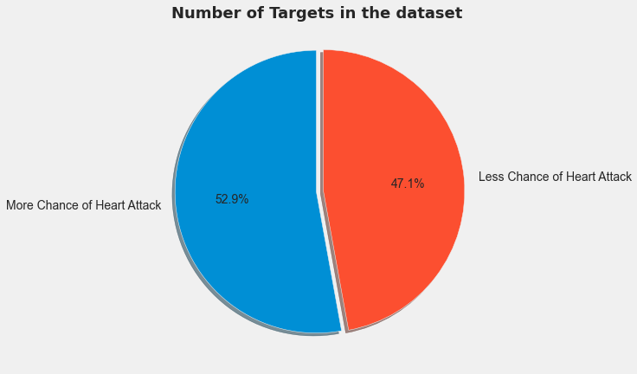
📌 From the above pie chart, we can see that we have relatively more people who have more chances of having a Heart Attack.

Heat Map Correlation
# Compute the correlation matrix
corr = data.corr()
# Generate a mask for the upper triangle
mask = np.triu(np.ones_like(corr, dtype=bool))
# Set up the matplotlib figure
f, ax = plt.subplots(figsize=(10, 8))
# Generate a custom diverging colormap
cmap = sns.diverging_palette(230, 20, as_cmap=True)
# Draw the heatmap with the mask and correct aspect ratio
sns.heatmap(corr, mask=mask, cmap=cmap, vmax=.3, center=0, square=True, linewidths=.5, cbar_kws={"shrink": .5})
<AxesSubplot:>
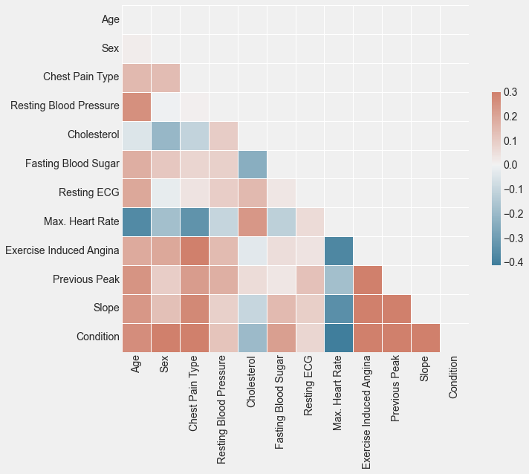
plt.figure(figsize=(10,9))
ax = sns.heatmap(corr, square=True, annot=True, fmt='.2f')
ax.set_xticklabels(ax.get_xticklabels(), rotation=90)
plt.show()
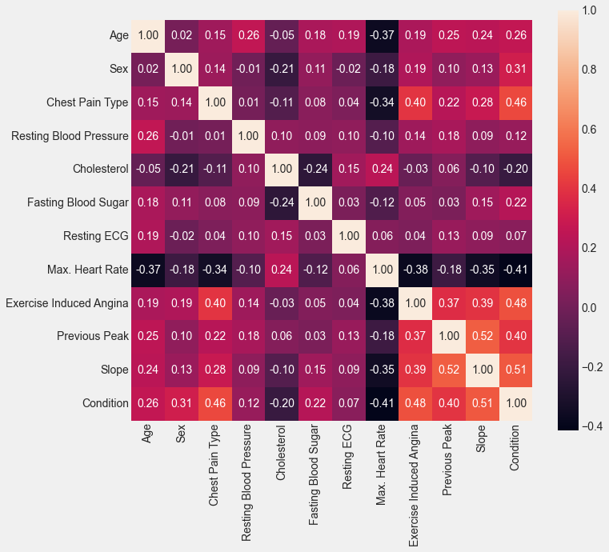
📌 From the above correlation matrix, we can see that the correlation between features is less.
📌 oldpeak i.e.ST depression induced by exercise relative to rest (‘ST’ relates to positions on the ECG plot) with the slope of the peak exercise ST segment and the slope of the peak exercise ST segment with Condition have high correlated features in our dataset; Correlation Coefficient of 0.52 and 0.51 respectively.
📌 Our features have a lot of negative correlation coefficient indicating that two individual variables have a statistical relationship such that generally move in opposite directions from one another.

Count Plot
# Count Plot of Categorical Data with Condition
j=0
fig=plt.figure(figsize=(10,10),constrained_layout =True)
plt.suptitle("Count of the Categorical Variables",y=1.07, family='Sherif', size=18, weight='bold')
fig.text(0.33,1.02,"Categorical Data with Condition", size=13, fontweight='light', fontfamily='monospace')
for i in data[categorical]:
ax=plt.subplot(241+j)
ax.set_aspect('auto')
ax.grid(color='gray', linestyle=':', axis='y', zorder=0, dashes=(1,5))
ax=sns.countplot(data=data, x=i, hue='Condition', alpha=1)
for s in ['left','right','top','bottom']:
ax.spines[s].set_visible(False)
j=j+1
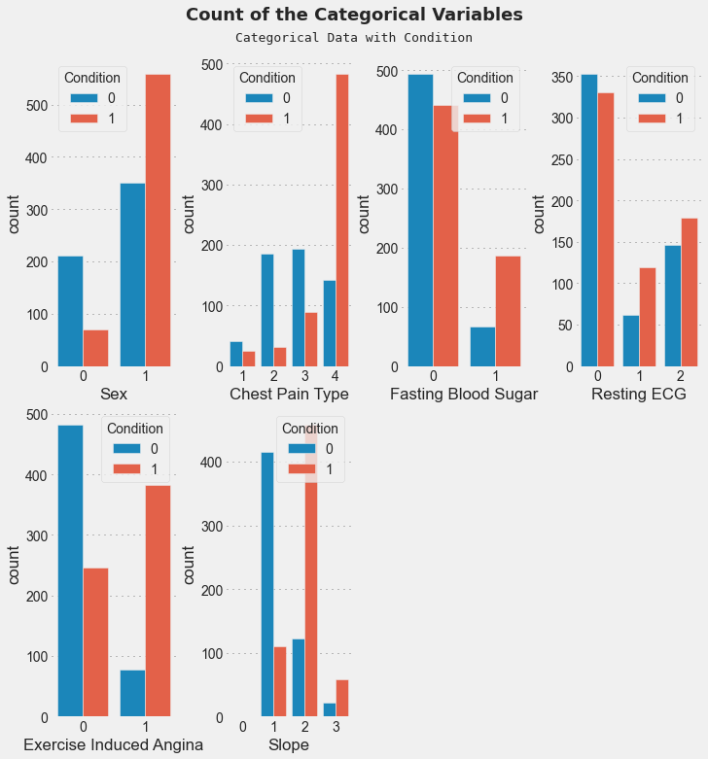
📌 From the above plots, we can see that we have different features which have a common and uncommon type of categories in our dataset.
📌 But, It is not enough to tell us about the features. Let's compare all the categorical features with the target column of Condition.
# Count Plot of Categorical Data with Condition
j=0
fig=plt.figure(figsize=(10,10),constrained_layout =True)
plt.suptitle("Count of the Categorical Variables",y=1.07, family='Sherif', size=18, weight='bold')
fig.text(0.33,1.02,"Categorical Data with Condition", size=13, fontweight='light', fontfamily='monospace')
for i in data[categorical]:
ax=plt.subplot(241+j)
ax.set_aspect('auto')
ax.grid(color='gray', linestyle=':', axis='y', zorder=0, dashes=(1,5))
ax=sns.countplot(data=data, x=i, hue='Condition', alpha=1)
for s in ['left','right','top','bottom']:
ax.spines[s].set_visible(False)
j=j+1
From above categorical plots we can see that:
📌 In Chest Pain, Type 0 has the highest number of people who have less chance of suffering from a heart attack.
📌 Fasting Blood Sugar and Resting ECG doesn't have much difference in their respective conditions.
📌 In Exercise-Induced Angina, Type 0 has the highest number of people who are likely to suffer a heart attack.
📌 Slope has Type 2 which shows people who are likely to suffer from a heart attack.

Distribution Plot
# Distribution Plot of Numerical Data w/o Condition
j=0
fig=plt.figure(figsize=(10,10),constrained_layout =True)
plt.suptitle("Distribution of the Numeric Variables",y=1.07, family='Sherif', size=18, weight='bold')
fig.text(0.315,1.02,"Numerical Data without Condition", size=13, fontweight='light', fontfamily='monospace')
for i in data[numerical]:
ax=plt.subplot(321+j)
ax.set_aspect('auto')
ax.grid(color='gray', linestyle=':', axis='x', zorder=0, dashes=(1,5))
ax=sns.kdeplot(data=data, x=i, fill=True, edgecolor='black', alpha=1)
for s in ['left','right','top','bottom']:
ax.spines[s].set_visible(False)
j=j+1
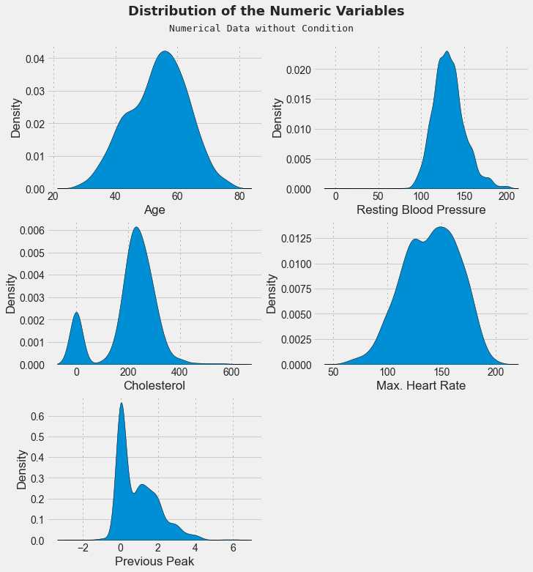
📌 From the above plots, we can see that the distribution density of different features them being skew. Let's also compare them with the target column of Condition to see how to perform.
# Distribution Plot of Numerical Data with Condition
j=0
fig=plt.figure(figsize=(10,10),constrained_layout =True)
plt.suptitle("Distribution of the Numeric Variables",y=1.07, family='Sherif', size=18, weight='bold')
fig.text(0.333,1.02,"Numerical Data with Condition", size=13, fontweight='light', fontfamily='monospace')
for i in data[numerical]:
ax=plt.subplot(321+j)
ax.set_aspect('auto')
ax.grid(linestyle=':', axis='x', zorder=0, dashes=(1,5))
ax=sns.kdeplot(data=data, x=i, hue='Condition', fill=True, edgecolor='black', alpha=1)
for s in ['left','right','top','bottom']:
ax.spines[s].set_visible(False)
j=j+1
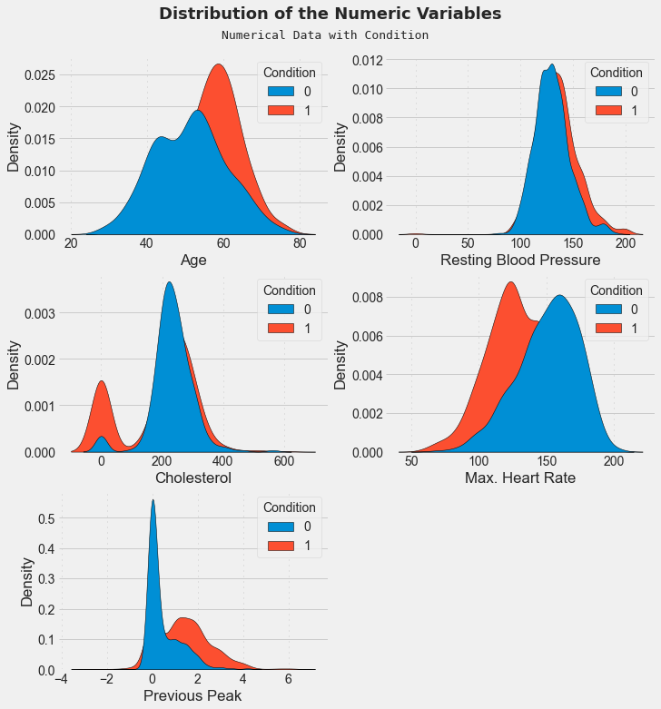
📌 From the above distribution plot, we can see that, Age and Max. Heart Rate is Negative Skewed and Resting Blood Pressure, Cholesterol, and Previous Peak are Positive Skewed.

Scatter Plot
# Scatter Plot of Numerical Data with Condition
num_cols = ['Resting Blood Pressure','Cholesterol','Max. Heart Rate','Previous Peak']
j=0
fig=plt.figure(figsize=(10,10),constrained_layout =True)
plt.suptitle("Scatter Plot of the Numeric Variables",y=1.07, family='Sherif', size=18, weight='bold')
fig.text(0.333,1.02,"Numerical Data with Condition", size=13, fontweight='light', fontfamily='monospace')
for i in data[num_cols]:
ax=plt.subplot(321+j)
ax.set_aspect('auto')
ax.grid(color='gray', linestyle=':', axis='x', zorder=0, dashes=(1,5))
ax=sns.scatterplot(data=data,x=data['Age'],y=i,hue=data['Condition'],ec='black')
for s in ['left','right','top','bottom']:
ax.spines[s].set_visible(False)
j=j+1
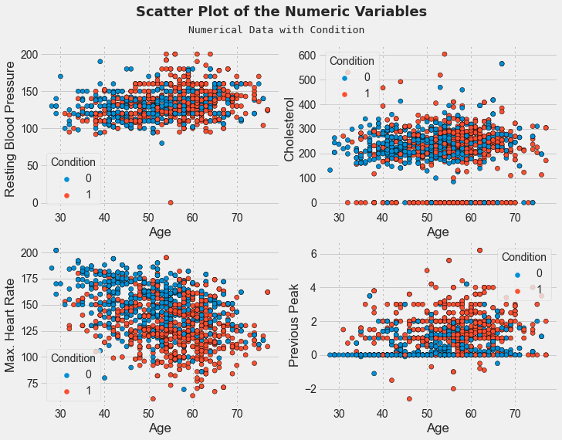
📌 From the above plot, we can see that the relationship between Age and different numerical features in our dataset with Condition. We can also few Outliers in our plot.

Outliers
📌 An outlier is an observation that lies an abnormal distance from other values in a random sample from a population.
Detection
📌 In this notebook, we are using Boxen Plot to detect the outliers of each features in our dataset, where any point above or below the whiskers represent an outlier. This is also known as “Univariate method” as here we are using one variable outlier analysis.
# Outliers Detection
plt.figure(figsize=(9,9))
plt.suptitle("Outliers of Numeric Variables",y=0.94, family='Sherif', size=18, weight='bold')
plt.text(-0.4, 1.64, 'Detecting Outliers in Numerical Columns', horizontalalignment='center',verticalalignment='center', transform=ax.transAxes,size=14,fontweight='light', fontfamily='monospace')
sns.boxenplot(data = data[numerical])
plt.grid( color='Black',linestyle=':', axis='y', zorder=0, dashes=(1,5))
plt.xticks(rotation=45)
plt.show()
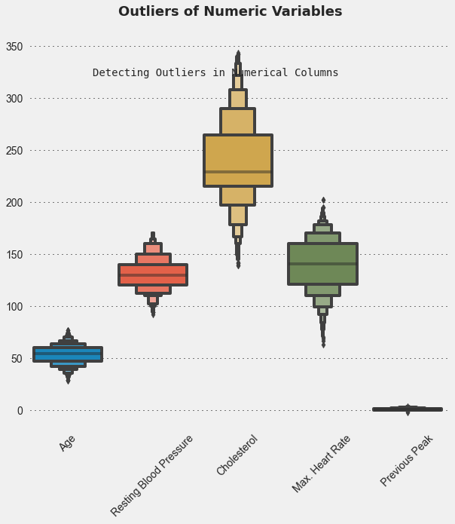

Removal
📌 After detecting, we are using Median Imputation to take care of outliers. In this technique, we replace the extreme values with median values.
📌 It is represented by the formula IQR = Q3 − Q1. The lines of code below calculate and print the interquartile range for each of the variables in the dataset.
📌 It is advised to not use mean values as they are affected by outliers.
# Removing Outliers
for i in data[numerical]:
q1 = data[i].quantile(0.25)
q3 = data[i].quantile(0.75)
iqr = q3-q1
Lower_tail = q1 - 1.5 * iqr
Upper_tail = q3 + 1.5 * iqr
med = np.median(data[i])
for j in data[i]:
if j > Upper_tail or j < Lower_tail:
data[i] = data[i].replace(j, med)
plt.figure(figsize=(9,9))
plt.suptitle("Outliers of Numeric Variables",y=0.94, family='Sherif', size=18, weight='bold')
plt.text(-0.405, 1.64, 'Removing Outliers in Numerical Columns', horizontalalignment='center',verticalalignment='center', transform=ax.transAxes,size=14,fontweight='light', fontfamily='monospace')
sns.boxenplot(data = data[numerical])
plt.grid( linestyle=':', axis='y', zorder=0, dashes=(1,5))
plt.xticks(rotation=45)
plt.show()
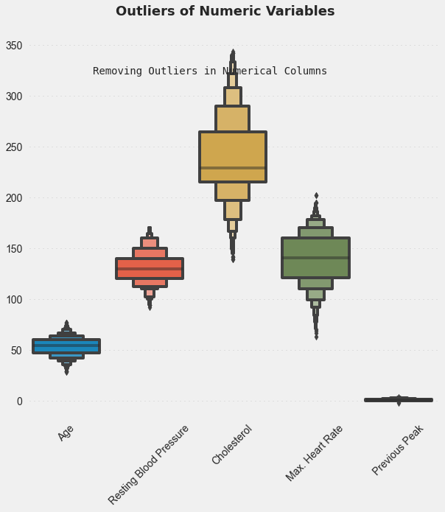

Data Preprocessing
x = data.iloc[:, :-1].values
y = data.iloc[:, -1].values
x
array([[40. , 1. , 2. , ..., 0. , 0. , 1. ],
[49. , 0. , 3. , ..., 0. , 1. , 2. ],
[37. , 1. , 2. , ..., 0. , 0. , 1. ],
...,
[57. , 1. , 4. , ..., 1. , 1.2, 2. ],
[57. , 0. , 2. , ..., 0. , 0. , 2. ],
[38. , 1. , 3. , ..., 0. , 0. , 1. ]])
# Splitting Data into Train and Test Set
from sklearn.model_selection import train_test_split
x_train, x_test, y_train, y_test = train_test_split(x, y, test_size= 0.2, random_state= 0)
print("Number transactions x_train dataset: ", x_train.shape)
print("Number transactions y_train dataset: ", y_train.shape)
print("Number transactions x_test dataset: ", x_test.shape)
print("Number transactions y_test dataset: ", y_test.shape)
Number transactions x_train dataset: (952, 11)
Number transactions y_train dataset: (952,)
Number transactions x_test dataset: (238, 11)
Number transactions y_test dataset: (238,)
# Feature Scaling with StandardScaler
#StandardScaler standardizes a feature by subtracting the mean and then scaling to unit variance.
from sklearn.preprocessing import StandardScaler
sc = StandardScaler()
x_train = sc.fit_transform(x_train)
x_test = sc.transform(x_test)
The goal of applying Feature Scaling is to make sure features are on almost the same scale so that each feature is equally important and make it easier to process by most ML algorithms.
StandardScaler results in a distribution with a standard deviation equal to 1.
StandardScaler does distort the relative distances between the feature values

Models
📌 True Positives (TP) - These are the correctly predicted positive values which means that the value of actual class is yes and the value of predicted class is also yes.
📌 True Negatives (TN) - These are the correctly predicted negative values which means that the value of actual class is no and value of predicted class is also no.
📌 False Positives (FP) – When actual class is no and predicted class is yes.
📌 False Negatives (FN) – When actual class is yes but predicted class in no.
📌 Accuracy - Accuracy is the most intuitive performance measure and it is simply a ratio of correctly predicted observation to the total observations. Accuracy = TP+TN/TP+FP+FN+TN
📌 Precision - Precision is the ratio of correctly predicted positive observations to the total predicted positive observations. Precision = TP/TP+FP
📌 Recall (Sensitivity) - Recall is the ratio of correctly predicted positive observations to the all observations in actual class - yes. Recall = TP/TP+FN
📌 F1 score - F1 Score is the weighted average of Precision and Recall. Therefore, this score takes both false positives and false negatives into account. F1 Score = 2(Recall Precision) / (Recall + Precision)
📌 Support - Support is the number of actual occurrences of the class in the specified dataset. Support doesn’t change between models but instead diagnoses the evaluation process.

Logistic Regression
📌 Logistic Regression assumes a Gaussian distribution for the numeric input variables and can model binary classification problems. You can construct a logistic regression model using the LogisticRegression class.
#Fitting Logistic Regression Model
classifier = LogisticRegression(random_state= 0)
classifier.fit(x_train, y_train)
y_pred_lr = classifier.predict(x_test)
y_prob = classifier.predict_proba(x_test)[:,1]
cm = confusion_matrix(y_test, y_pred_lr)
print(classification_report(y_test, y_pred_lr))
print('Accuracy Score: ',accuracy_score(y_test, y_pred_lr))
precision recall f1-score support
0 0.83 0.78 0.80 109
1 0.82 0.86 0.84 129
accuracy 0.82 238
macro avg 0.82 0.82 0.82 238
weighted avg 0.82 0.82 0.82 238
Accuracy Score: 0.8235294117647058
# Visualizing Confusion Matrix
plt.figure(figsize = (6, 6))
sns.heatmap(cm, cmap = 'Greens', annot = True, fmt = 'd', linewidths = 5, cbar = False, annot_kws = {'fontsize': 15})
plt.xlabel('Predicted Label')
plt.ylabel('True Label')
plt.yticks(rotation = 0)
plt.show()
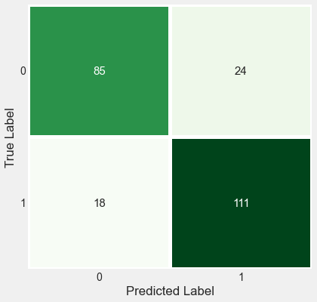

K-Nearest Neighbors
📌 The k-nearest neighbors (KNN) algorithm is a simple, easy-to-implement supervised machine learning algorithm that can be used to solve both classification and regression problems
#Fitting KNeighborsClassifier Model
classifier = KNeighborsClassifier()
classifier.fit(x_train, y_train)
y_pred_KNN = classifier.predict(x_test)
y_prob = classifier.predict_proba(x_test)[:,1]
cm = confusion_matrix(y_test, y_pred_KNN)
print(classification_report(y_test, y_pred_KNN))
print('Accuracy Score: ',accuracy_score(y_test, y_pred_KNN))
precision recall f1-score support
0 0.88 0.83 0.85 109
1 0.86 0.91 0.88 129
accuracy 0.87 238
macro avg 0.87 0.87 0.87 238
weighted avg 0.87 0.87 0.87 238
Accuracy Score: 0.8697478991596639
# Visualizing Confusion Matrix
plt.figure(figsize = (6, 6))
sns.heatmap(cm, cmap = 'Blues', annot = True, fmt = 'd', linewidths = 5, cbar = False, annot_kws = {'fontsize': 15})
plt.xlabel('Predicted Label')
plt.ylabel('True Label')
plt.yticks(rotation = 0)
plt.show()
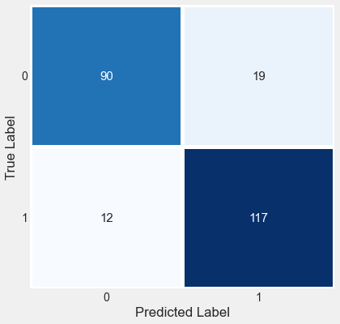

Naive Bayes Classifier
📌 A Gaussian Naive Bayes algorithm is a special type of NB algorithm. It's specifically used when the features have continuous values. It's also assumed that all the features are following a gaussian distribution i.e, normal distribution.
#Fitting GaussianNB Model
classifier = GaussianNB()
classifier.fit(x_train, y_train)
y_pred_NB = classifier.predict(x_test)
y_prob = classifier.predict_proba(x_test)[:,1]
cm = confusion_matrix(y_test, y_pred_NB)
print(classification_report(y_test, y_pred_NB))
print('Accuracy Score: ',accuracy_score(y_test, y_pred_NB))
precision recall f1-score support
0 0.81 0.82 0.81 109
1 0.84 0.84 0.84 129
accuracy 0.83 238
macro avg 0.83 0.83 0.83 238
weighted avg 0.83 0.83 0.83 238
Accuracy Score: 0.8277310924369747
# Visualizing Confusion Matrix
plt.figure(figsize = (6, 6))
sns.heatmap(cm, cmap = 'Blues', annot = True, fmt = 'd', linewidths = 5, cbar = False, annot_kws = {'fontsize': 15})
plt.xlabel('Predicted Label')
plt.ylabel('True Label')
plt.yticks(rotation = 0)
plt.show()
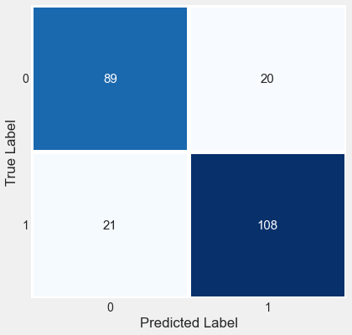

Decision Tree (CART)
📌 Classification and Regression Trees (CART or just decision trees) construct a binary tree from the training data. Split points are chosen greedily by evaluating each attribute and each value of each attribute in the training data in order to minimize a cost function (like the Gini index). You can construct a CART model using the DecisionTreeClassifier class
#Fitting DecisionTreeClassifier Model
classifier = DecisionTreeClassifier(criterion= 'gini',random_state= 0)
classifier.fit(x_train, y_train)
y_pred_dtcart = classifier.predict(x_test)
y_prob = classifier.predict_proba(x_test)[:,1]
cm = confusion_matrix(y_test, y_pred_dtcart)
print(classification_report(y_test, y_pred_dtcart))
print('Accuracy Score: ',accuracy_score(y_test, y_pred_dtcart))
precision recall f1-score support
0 0.89 0.91 0.90 109
1 0.92 0.91 0.91 129
accuracy 0.91 238
macro avg 0.91 0.91 0.91 238
weighted avg 0.91 0.91 0.91 238
Accuracy Score: 0.907563025210084
# Visualizing Confusion Matrix
plt.figure(figsize = (6, 6))
sns.heatmap(cm, cmap = 'Blues', annot = True, fmt = 'd', linewidths = 5, cbar = False, annot_kws = {'fontsize': 15})
plt.xlabel('Predicted Label')
plt.ylabel('True Label')
plt.yticks(rotation = 0)
plt.show()
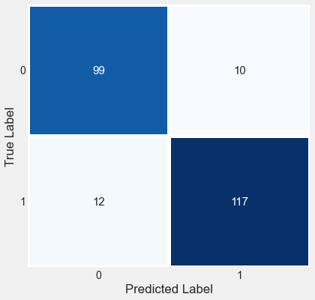

Random Forest
📌 Random Forests is an extension of bagged decision trees. Samples of the training dataset are taken with replacement, but the trees are constructed in a way that reduces the correlation between individual classifiers. Specifically, rather than greedily choosing the best split point in the construction of each tree, only a random subset of features are considered for each split. You can construct a Random Forest model for classification using the RandomForestClassifier class.
#Fitting RandomForestClassifier Model
classifier = RandomForestClassifier(criterion= 'entropy', n_estimators= 200,random_state= 0)
classifier.fit(x_train, y_train)
y_pred_rfor = classifier.predict(x_test)
y_prob = classifier.predict_proba(x_test)[:,1]
cm = confusion_matrix(y_test, y_pred_rfor)
print(classification_report(y_test, y_pred_rfor))
print('Accuracy Score: ',accuracy_score(y_test, y_pred_rfor))
precision recall f1-score support
0 0.95 0.91 0.93 109
1 0.93 0.96 0.94 129
accuracy 0.94 238
macro avg 0.94 0.93 0.94 238
weighted avg 0.94 0.94 0.94 238
Accuracy Score: 0.9369747899159664
# Visualizing Confusion Matrix
plt.figure(figsize = (6, 6))
sns.heatmap(cm, cmap = 'Reds', annot = True, fmt = 'd', linewidths = 5, cbar = False, annot_kws = {'fontsize': 15})
plt.xlabel('Predicted Label')
plt.ylabel('True Label')
plt.yticks(rotation = 0)
plt.show()
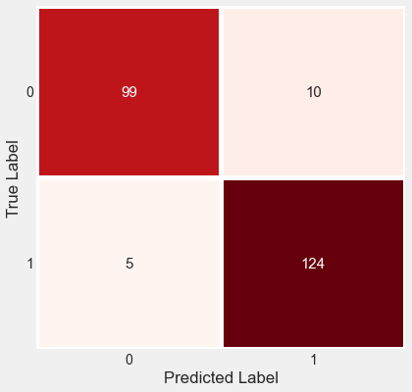
dist={"Model":['Logistic Regression','K-Nearest Neighbors','Naive Bayes Classifier','Decision Tree (CART)','Random Forest'],
"Accuracy Percentage":[82.35,86.97,82.77,90.75,93.69]}
Model_Accuracy=pd.DataFrame(dist)
Model_Accuracy
Model Accuracy Percentage
0 Logistic Regression 82.35
1 K-Nearest Neighbors 86.97
2 Naive Bayes Classifier 82.77
3 Decision Tree (CART) 90.75
4 Random Forest 93.69
prediction=classifier.predict([[56,1,4,132,184,0,2,105,1,2.1,2]])
prediction
array([1], dtype=int64)

